Teach it to ‘Em: Short Stories
Directions: in your groups you will read one of two short stories. Along the way, be sure to mark the text for the following literary devices we have been discussing in class. Make notes here and transfer to the large sticky poster. Once you have completed all steps, your group will teach the class about your particular portion of the short story. Be sure to be thorough so that your classmates feel as if they too read the story.

Roles
Each group member should have a role. Please decide below who will play which role. Everyone must participate. If you have more members than roles, you may double up on reader, marker, and poster creator.
Facilitator (keep all members engaged and focused):___________________________________
Reader (reading of the story to the group): ___________________________________
Marker (will be the key annotator and will make sure all members annotate the same pieces of information): ___________________________________
Poster Creator (create of poster for the group): ___________________________________
All members should record their notes below.

Plot
Fill out the plot diagram.
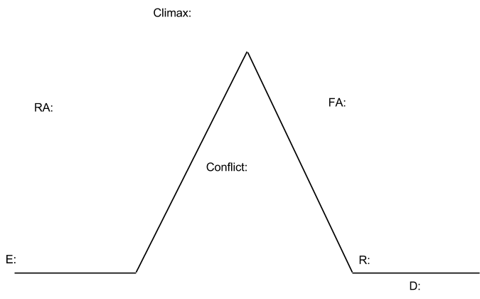

Characterization
- Description
- Motivation
- Interaction with others

Connotation
Find three examples where the author uses connotation as a tool to express their feelings about a character or event within the story. Use “Boys and Girls” as a reference. Be sure to properly quote, use page numbers, and provide an explanation of the connotation being used.

