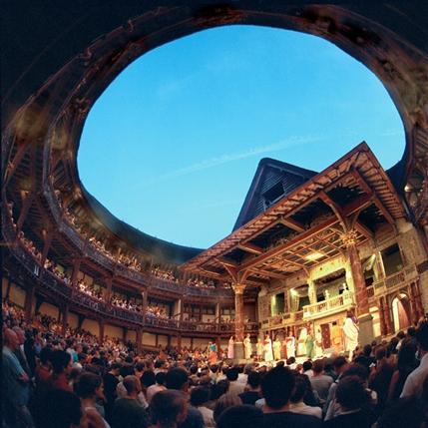
History of Drama – Web Quest
Introduction
“I regard the theatre as the greatest of all art forms, the most immediate way in which a human being can share with another the sense of what it is to be a human being.” ~
Oscar Wilde
To begin our unit on drama, you will be exploring the History of Drama. In this Web Quest, you and your partner/group will research and discover some of the most important pieces of Drama’s History.
Task
As a pair, you will:
- Create a visual display of what you have learned – this could be a PowerPoint presentation, slide show, or poster
- Present the information you discovered creatively
- Make a connection to the research you found – how does it relate to your current knowledge as well as how you think it will help your understanding of our play, “Much Ado About Nothing”
Process
Step 1
Together, you and your partner/group will choose one of the topics below. You have been given 2 questions relating to your topic. You and your partner/group are responsible for coming up with 2-4 additional questions for exploration. Complete the first and second column of the KWL chart about your chosen topic. The third column, “What I Learned”, will be completed as part of your Reflection, at the end of the assignment.
Step 2
Before beginning your research, divide the topic into subtopics. Think about the 5 Ws: who, what, where, when, why; use these to develop your subtopics.

Step 3
Begin researching your topic! Record your findings on a word document or on notebook paper. Be sure to record the sources you are using for each piece of information you find. DO NOT COPY AND PASTE!! I WILL BE CHECKING!!! Be sure to discuss all your subtopics you created in Step 2.
Step 4
Develop the visual display. Be sure to use pictures, graphic selections (ex. – timelines, charts, maps, etc.), important quotes and other interesting information. Be creative and unique!
Topics
- History of Masks – Greek Theatre
- History of Masks – Renaissance Italy
- African Drama History
- Chinese Drama History
- Elizabethan Theatre
- Theatre of the Absurd
- Theatre of the Oppressed
- Kabuki Theatre
- Musical Theatre History
- Careers in Theatre
- Greek Drama
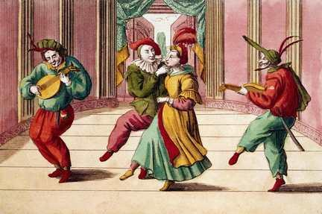
Resources – Online
History of Masks – Greek Theatre
http://www.didaskalia.net/issues/vol6no1/varakis.html
http://www.didaskalia.net/issues/vol7no1/vovolis_zamboulakis.html
http://www.theatrehistory.com/ancient/greek.html
Questions:
- Why were masks used in Greek Theatre?
- When did masks begin to be used in Greek Theatre?

History of Masks – Renaissance Italy
http://www.theatrehistory.com/italian/commedia_dell_arte_001.html
http://www.britannica.com/EBchecked/topic/127742/commedia-dellarte
http://www.bbc.co.uk/dna/h2g2/A593589
Questions:
- What was the commedia dell’arte?
- Why were masks used in the commedia dell’arte?

African Drama History
https://openaccess.leidenuniv.nl/bitstream/1887/7769/1/05_090_048.pdf
EBSCO-Art&Architecture Complete – “A national Negro theater that never was”
EBSCO-History Reference Centre – “The Origins of African-American Performing Arts”
Questions:
- How is African American drama distinct from other forms of drama?
- Where did African American drama originate?

Chinese Drama History
http://www.theatrehistory.com/asian/chinese004.html
http://www.theatrehistory.com/asian/chinese001.html
http://www.questia.com/read/9977861?title=Chinese%20Theater%3a%20From%20Its%20Origins%20to%20the%20Present%20Day
http://sinology.chinahand.net/eric-7/drama.htm
Questions:
- What is the Chinese opera?
- What are some of the subjects of Chinese drama?

Elizabethan Theatre
http://www.elizabethan-era.org.uk/history-of-the-elizabethan-theatre.htm
http://www.bartleby.com/60/203.html
http://www.bardweb.net/globe.html
http://www.theatrehistory.com/british/bellinger001.html
http://www.princeton.edu/~achaney/tmve/wiki100k/docs/English_Renaissance_theatre.html
Questions:
- Why is Elizabethan theatre so important in the history of drama?
- What is the significance of the Globe Theatre?

Theatre of the Absurd
http://www.theatredatabase.com/20th_century/theatre_of_the_absurd.html
http://www.arts.gla.ac.uk/Slavonic/Absurd.htm
Questions:
- What is Theatre of the Absurd?
- Compare and contrast East and West Theatre of the Absurd.

Theatre of the Oppressed
http://www.theatreoftheoppressed.org/en/index.php?useFlash=0
http://www.theatreoftheoppressed.com/
Questions:
- What is Theatre of the Oppressed?
- Who is Augusto Boal and why is he such an important figure in Drama?

Kabuki Theatre
http://www.theatrehistory.com/asian/kabuki001.html
http://www.britishmuseum.org/explore/online_tours/japan/kabuki_theatre_of_japan/kabuki_theatre_of_japan.aspx
Questions:
- Where did Kabuki Theatre originate?
- What were Kabuki Theatre performances about?

Musical Theatre History
http://www.thecanadianencyclopedia.com/index.cfm?PgNm=TCE&Params=U1ARTU0002501
http://www.helium.com/items/365143-the-history-of-musical-theater
Questions:
- What are some examples of Canadian Pop Operas and why are they important?
- When and where did Musical Theatre originate?

Careers in Theatre
http://www.getintotheatre.org/jobs
http://www.utm.utoronto.ca/~w3car/pdf/TheatrePanel.pdf
Questions:
- What are the four categories of Theatre-based careers?
- What are some ``Creative`` jobs that do not consist of being on stage?

Greek Drama
http://academic.reed.edu/humanities/110tech/theater.html
http://www.cwu.edu/~robinsos/ppages/resources/Theatre_History/Theahis_2.html
http://www.metmuseum.org/toah/hd/thtr/hd_thtr.htm
Questions:
- What was the importance of Greek drama?
- How were plays performed and in what type of venue?

KWL Chart
Topic ________________________________________
Group Members __________________________________________________________________

What I Know | What I Want to Know | What I Learned

Evaluation
History of Drama Web Quest: Rubric
Rubric: Research, Display and Presentation
 | Level R  (0-70) | Level 1  (71-78) | Level 2  (79-85) | Level 3  (86-92) | Level 4  (93-100)
Knowledge/ Understanding | • Demonstrates little or no understanding of content of chosen topic | • Demonstrates limited understanding of content of chosen topic | • Demonstrates some understanding of content of chosen topic | • Demonstrates understanding of content of chosen topic | • Demonstrates thorough understanding of content of chosen topic
Thinking / Inquiry | • Uses critical / creative thinking skills with little or no effectiveness (through choice of visual elements and facts included) | • Uses critical / creative thinking skills with limited effectiveness (through choice of visual elements and facts included) | • Uses critical / creative thinking skills with some effectiveness (through choice of visual elements and facts included) | • Uses critical / creative thinking skills with effectiveness (through choice of visual elements and facts included) | • Uses critical / creative thinking skills with high degree of effectiveness (through choice of visual elements and facts included)
Communication | • Visual display communicates information with little or no effectiveness | • Visual display communicates information with limited effectiveness | • Visual display communicates information with some effectiveness | • Visual display communicates information with effectiveness | • Visual display communicates information with a high degree of effectiveness
Application | • Transfers knowledge and skills to role play performance with little or no effectiveness | • Transfers knowledge and skills to new context with limited effectiveness | • Transfers knowledge and skills to new context with some effectiveness | • Transfers knowledge and skills to new context with effectiveness | • Transfers knowledge and skills to new context very effectively
